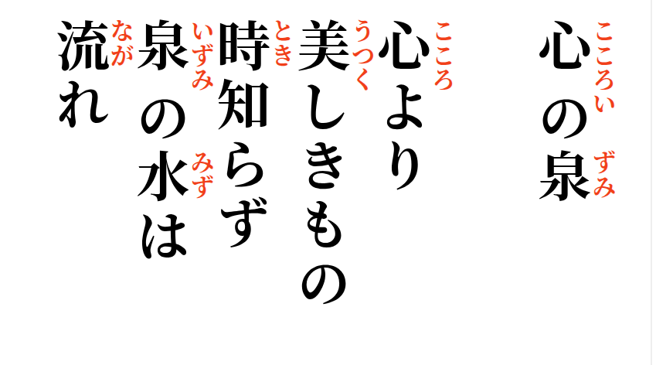

2026-09-11
The Spring Within

What comes from the heart—
beauty knows nothing of time;
like a hidden spring,
its clear water keeps flowing
beneath the changing years.

